Personal Internal Blockchain Activity Review
Black Screen Display and Public Blockchain Evidence
Prepared for private internal review
10 August 2026
PERSONAL INTERNAL REVIEW — NOT A BANK CERTIFICATE — NOT PROOF OF FUNDS

1. Purpose and scope
This report organizes user-provided Black Screen information and public Bitcoin explorer screenshots for personal recordkeeping. It does not certify ownership of any wallet, attribute third-party mining-pool activity to the user, verify a bank balance, establish lawful source of funds, or confirm conversion of cryptocurrency into fiat currency.

2. Black Screen information supplied by the user
Field | Displayed value | Evidentiary classification
Document-terminal reference | 8000040326015780 | User-provided display
Foreign-currency balance | EUR 684,820,310.83 | Displayed / independently unverified
Domestic-currency balance | USD 0.00 | Displayed / independently unverified
Connection label | CONNECTED [100%] | Interface text only
Certificate label | VERIFIED | Interface text only; no certificate chain supplied
Document label | HSBC_UK_RWA_PROFESSIONAL_CURRENT.pdf | Embedded/displayed document name
The displayed EUR balance is reproduced only as information visible in the supplied HTML. No bank statement, authenticated bank API response, signed ledger extract, or independent financial-institution confirmation was supplied.

3. Public Bitcoin address activity
The supplied screenshot displays Bitcoin address 1BM1sAcrfV6d4zPKytzziu4McLQDsFC2Qc, labelled Spider Pool. The screenshot shows high-volume mining-pool activity and a displayed balance of approximately 108.77902557 BTC at the time captured.
This address is a public mining-pool address. Activity of the pool is not evidence of the user’s ownership or income. A valid income attribution requires a payout transaction from the pool to an address demonstrably controlled by the user.
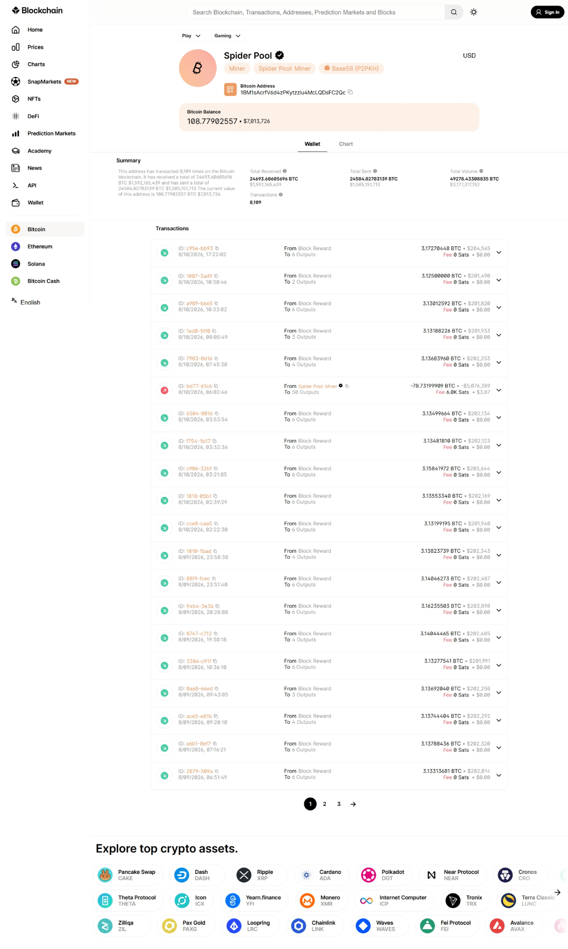
User-provided SpiderPool address screenshot

4. Submitted Bitcoin transaction
Field | Observed value
Network | Bitcoin
Transaction ID | 900d114ebb2cd6f9daae5f4474a0f7dce9292d51c5478810fa21939c19fb885f
Timestamp displayed | 22 May 2026, 06:08:22
Input value displayed | 0.63647173 BTC
Classification displayed | Batch payment
Confirmation state | Confirmed on the public blockchain
Output pattern | Hundreds of outputs; many visible outputs equal 0.00000546 BTC
Ownership attribution | Not established
Income attribution | Not established
The Miner: Foundry USA label identifies the miner of the block containing the transaction. It does not identify the sender, beneficial owner, or source of funds.
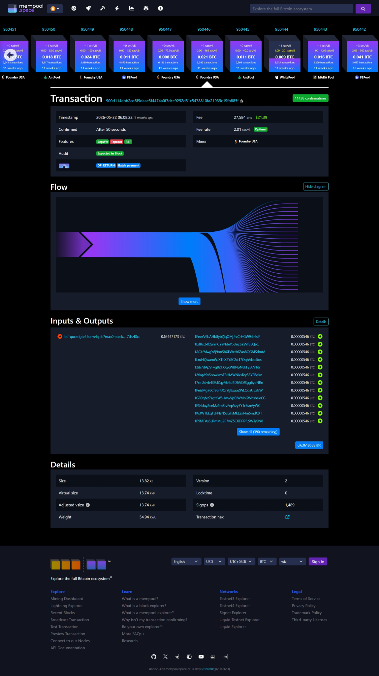
User-provided transaction explorer screenshot

5. Relationship assessment
Question | Finding
Does the blockchain transaction exist? | Yes — the supplied TxID is shown as confirmed.
Does the screenshot prove that the user owns an output address? | No.
Does the SpiderPool page prove user mining income? | No; it shows public pool activity.
Does the Black Screen prove the displayed EUR balance? | No; it is a user-provided interface display.
Is a link between the Bitcoin activity and EUR 684,820,310.83 established? | No.
Can this report be used as a bank certificate or proof of funds? | No.

6. Current internal conclusion
Blockchain transaction: CONFIRMED ON-CHAIN
Mining-pool activity: PUBLIC THIRD-PARTY ACTIVITY
Wallet ownership: NOT ESTABLISHED
Income attribution: NOT VERIFIED
Black Screen balance: DISPLAYED / UNVERIFIED
Blockchain-to-fiat linkage: NOT ESTABLISHED

7. Evidence needed for a verified source-of-funds conclusion
- The exact payout TxID from the mining pool to the user’s receiving address.
- Proof that the receiving address is controlled by the user, preferably a signed wallet message.
- Mining account export, payout statement, mining/hosting agreement, or equipment records.
- A transaction-level schedule reconciling each payout to the declared income.
- Evidence of any exchange or OTC conversion from BTC into EUR.
- A bank statement or authenticated institutional record matching the fiat proceeds.
- Identity and company records sufficient for AML/source-of-funds review.

8. Integrity register
Supplied item | SHA-256
Black Screen HTML | 5bc222bd253827356d1431e13b3a1269bb80821f678ca3c84a0c0ba86a817524
SpiderPool address screenshot | 636b9cbbdd93ab9b6954c54cfc933a8cf65d72fb97711709fb7762399dd37f39
SpiderPool full-page screenshot | 5f145af977f890f15ca2b6e15d1ef620a56e3caa2b68b5e74f285e1cdc39483b
Bitcoin transaction screenshot | 8e6f56207c392f9cf5af67bd1d4bb95341a7a0ce4014753a79224c1abd7b3d0c

Restriction: This document is a personal analytical record compiled from user-provided material. It must not be represented as issued, approved, verified, or endorsed by SWIFT, HSBC, Blockchain.com, Mempool.space, SpiderPool, Foundry USA, a bank, an auditor, or a regulatory authority.

